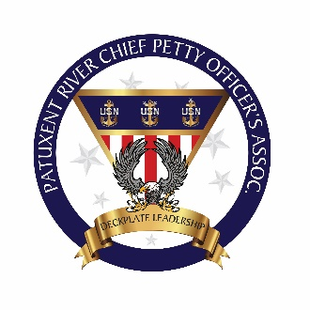

CPOA GA Minutes of Meeting

1. The GA meeting was started at 1300 on November 6, 2019.
2. The following persons were present:
   * + - * Members Present: 31
         * Guests present: 0
3. OLD BUSINESS
   * + - * Swag Person/Hail and Farewell
4. Treasurer CPO Luis Restrepo:

* In Checking: $ 2,785.00
* In Savings: $ 4,383.40
* Cash on Hand: $00.00
* Total Balance: $ 7,168.40
* Current Members in good standing:
* Overdue on dues:
* Current Lifetime Members:
* Total Members: 237 as of October 2019

**New Members**

**New Lifetime Members**

**Departing Members**

Christopher Reid

Terrence Rivers

Adam Arnstein

4. NEW BUSINESS

* + - There will be a $50.00 deposit from member(s) who desire the use “Chief’s Meat” grill. This deposit is non-refundable unless the grill is cleaned and properly stored after use. Additionally, a $25.00 rental fee will be charged to non-member who wants to use the grill.
    - **Announcements:**

(1) As a result of NAS “Barracks Program”, additional 260 rooms will be available soon as new building construction is being completed.

(2) Be a “RECORDER”. CPO’s are highly encourage to be a recorder for the FY 21 CPO selection board process. See Tim McKinley if interested for additional guidance.

(3) As a result of the 2019 Navy League Matt Budde were able to donate $500.00 to the Mess. Thanks Matte!

**House: (Brad)**

* Nov 9 at 0930 is house clean up. Volunteers are needed to help tidy up the mess. Future dates will be announce.

**Com Rel Committee:** **(Stu)**

**Training and Heritage Committee: (Raffy)**

**Upcoming Events:** **(Axel)**

* Thanks Giving Potluck, lunch time from 1100 to 1400.
* Holiday Potluck (date and time will be announced soon)
* Right Hand Man (date and time will be announced soon)

1. The meeting was adjourned at 1600. The next meeting is scheduled for Dec 4, 1400 at the goat locker.

__________________________ __________________________

PSC Walter Vergara AMCS Stephen Rolka

Secretary President

Date: Date: