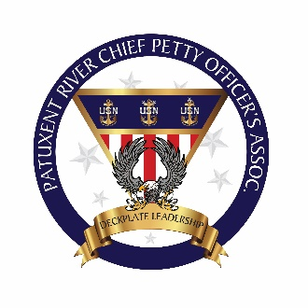

CPOA General Assembly Script

1. The May Pax River CPOA General Assembly was called to order at 1130 on May 1, 2019.
2. The following persons were present:
   * + - * Members Present: 28
         * Guests present:
3. OLD BUSINESS
   * + - * Swag Person/Hail and Farewell
4. Treasurer CPO Dan Shaner:

We have $6,646.48in Checking, $3810.00 in Savings and $61.43 cash on hand for a grand total of $10,517.91

**New Members**

* None at this time

**New Lifetime Members**

* Hugh McClafferty

**Departing Members**

* Keisha Padmore
* Sheldon Hunter
* Kevin Guy
* Robert Powell II
* Hugh McClafferty

1. NEW BUSINESS
   * + Softball team sign-ups – POC Mark Reed

**House:**

Input from the house is to mention the Square POS terminal, Mark has adjusted prices to include the 2.75% charge for the service. So, if you pay your annual dues it will be a charge of $102.75 or a bar card will be a charge of $20.55. Still cheaper than the walk of shame to the ATM with a $3 fee.

Please pay for items you take from the mess, honor system is in effect.

A plug for more attendance, it doesn't mean you have to drink to just come hang out with your brothers and sisters for a few minutes after work. We will have more non-alcoholic available like Coke, Coke Zero, Dr. Pepper, orange soda, ginger ale, Mt Dew as well as the usual snacks. If there is a request for something specific, please let the house know and we will look into getting it stocked.

Floor Options for the CPOA has been decided, Mark Reed will speak in detail about the selected option and plan proceeding forward

HANGAR currently undergoing renovations. Horseshoe pits will also go under renovations.

Tiles and Bar Siding Plaques available for purchase.

**Com Rel Committee:** **(Minh Le)**

* Meals on Wheels Community Opportunities
* May 8th, 2019
* May 15th, 2019
* May 22nd, 2019
* May 29th, 2019

**Training and Heritage Committee: (Jason Hickenbottom)**

* Flying Chiefs

**Upcoming Events:** **(Walt Vergara)**

* Upcoming Events: (Walt Vergara)Cinco De Mayo @1600-Midnight
* Next Right Hand Man Luncheon slated for June (June Time Frame)

1. The meeting was adjourned at 1215. The next meeting is scheduled for June 5th, 2019 at 1530 at the goat locker.

Wybe De Vries Stephanie Dee __________________________ ___________________________

AOC (AW) Wybe DeVries CTIC(NAC/AW) Stephanie Dee

Secretary Vice President

Date: May 1, 2019 Date: May 1, 2019